**SMART FARMING USING IOT**

**SPRINT DELIVERY-3**

**TEAM ID:** **PTN2022TMID52243**

**HOME SCREEN CREATION:**

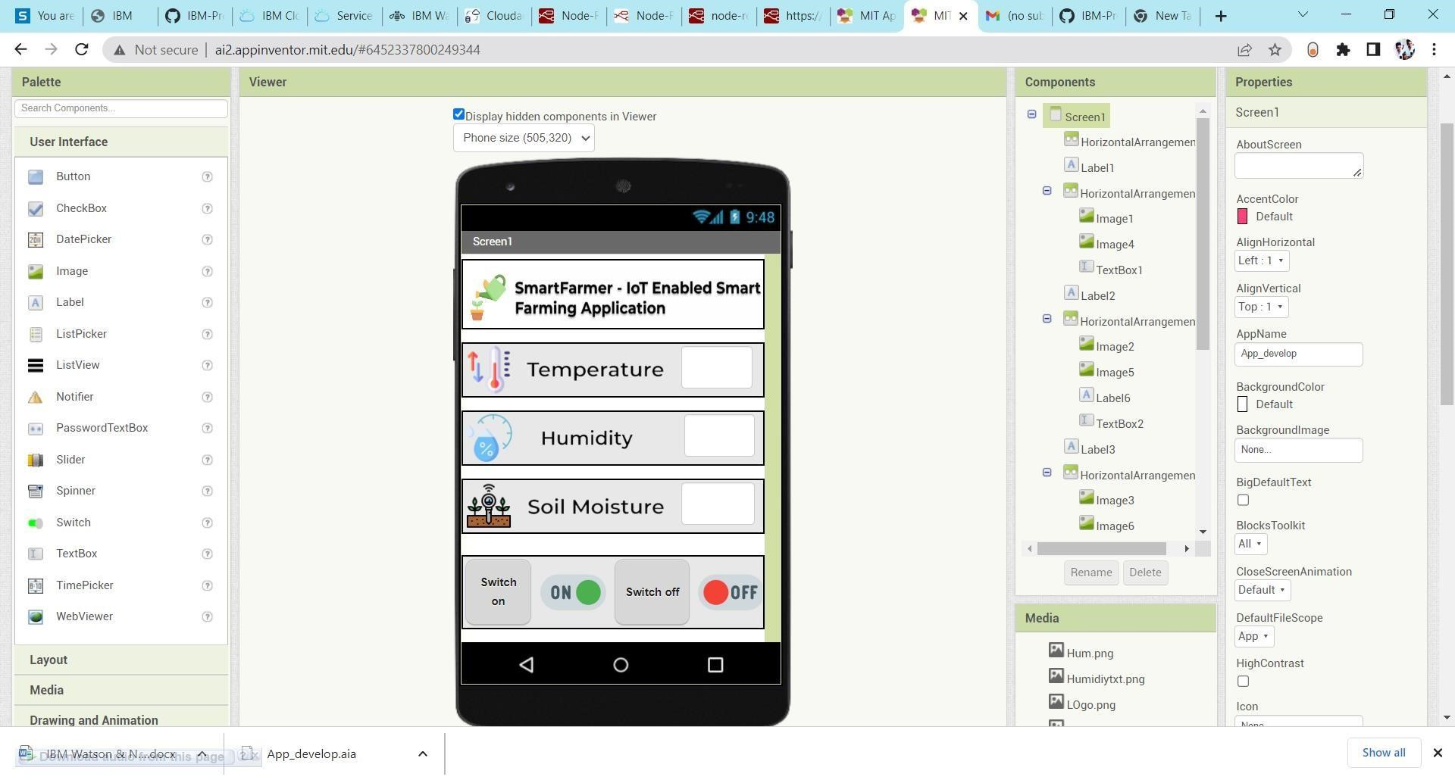

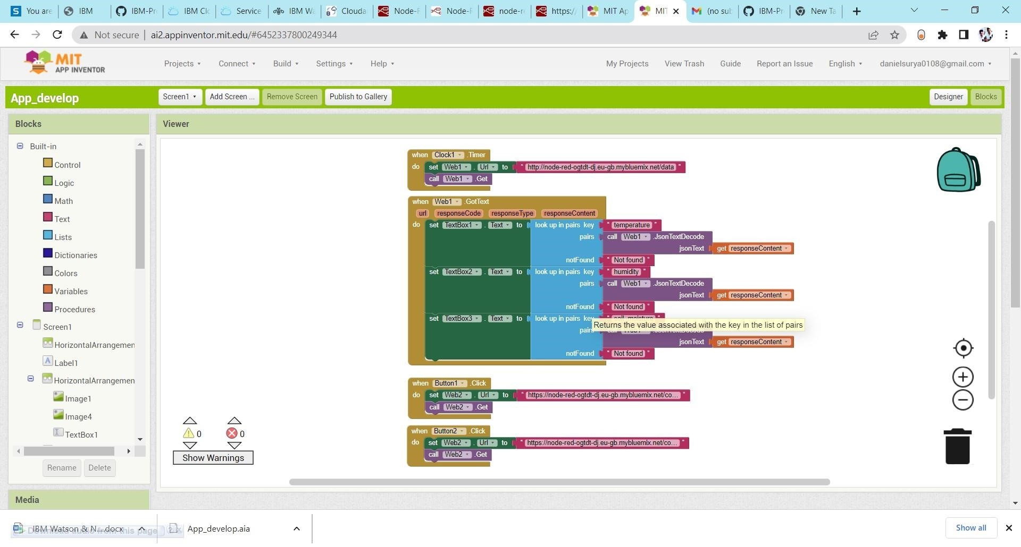**BLOCKS CREATION:**

**MOBILE APPLICATION:**

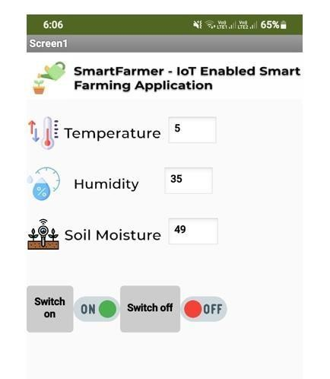

**CLOUDANT DB:**

